Subject: Explanation Required for Unauthorized Absence Without Leave - Saleem Farooq (MTS).
You were found absent from your duties without official leave on 24-07-2025.This unauthorized absence is a grave breach of the attendance and leave policies, which strictly require all employees to obtain prior approval for any absence. You have been found habitual of remaining absent without prior approval.
You are hereby directed to submit a comprehensive written explanation for your unauthorized absence within two (2) calendar days from the date of this notice. Your explanation must clearly detail the reasons for your absence.
Be informed that failure to provide a satisfactory explanation within the stipulated two-day period will result in immediate and severe disciplinary action, as per the established rules and regulations.

No: KGP/Estt/2025/690-691
Dated:24-07-2025
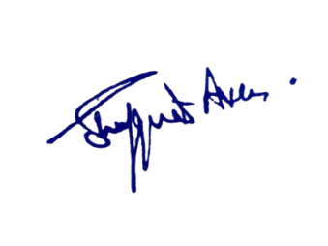

Principal
Kashmir Government Polytechnic College
Srinagar

Copy to the:
1.Director,Skill Development Department for information.

